🏗️ Event-Driven DIS Modernization Architecture
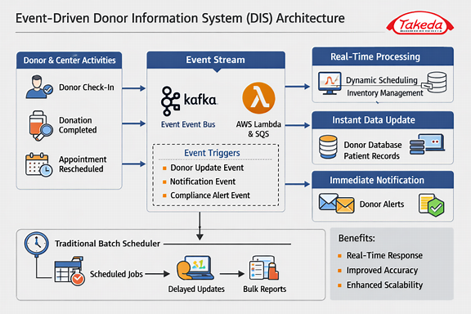

POC Roadmap

Day 1 – Setup
- Create Angular frontend with a simple donor check-in form.
- Deploy AWS API Gateway to route requests securely.
- Build a .NET Core Producer Service that accepts donor actions and publishes events.
Day 2 – Event Bus
- Install and configure Kafka locally (or use AWS MSK).
- Alternatively, set up AWS SQS queue.
- Implement producer logic in .NET Core:
Day 3 – Consumer Services
- Create Donor Service in .NET Core: consumes events, updates AWS RDS.
- Create Notification Service: consumes events, sends SMS/email via AWS SNS.
- Create Compliance Service: logs events for audit trail.
Day 4 – AWS RDS Integration
- Provision AWS RDS (PostgreSQL/MySQL).
- Define schema:
sql
CREATE TABLE Donors (
DonorId VARCHAR(50) PRIMARY KEY,
Name VARCHAR(100),
Status VARCHAR(50),
LastCheckIn TIMESTAMP
);
- Consumer updates donor records in real time.

Day 5 – Notifications
- Configure AWS SNS topic for donor alerts.
- Subscribe email/SMS endpoints.
- Consumer publishes notification events:
Day 6 – Monitoring & Observability
- Enable AWS CloudWatch metrics for queues, RDS, and Lambda.
- Add structured logging in .NET Core with Serilog.
- Implement dead-letter queues for failed messages.
- Apply Monitoring Driven Development (MDD): embed metrics in code.
Day 7 – End-to-End Demo
- Donor submits check-in via Angular.
- API Gateway → .NET Core Producer → Kafka/SQS.
- Consumers update RDS, send notifications, log compliance.
- Verify real-time updates in DB and notifications.
- Show CloudWatch dashboard for monitoring.

